WEEK 2 GITHUB PROOF

- Feature-Branch-Creation
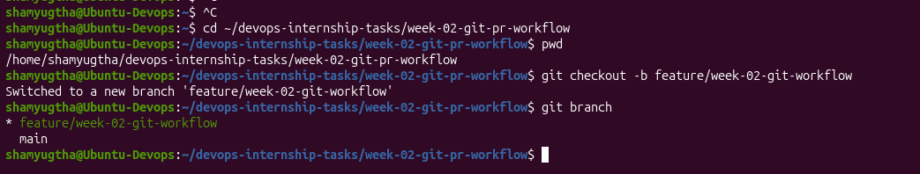

- Feature-Branch-Commit-History
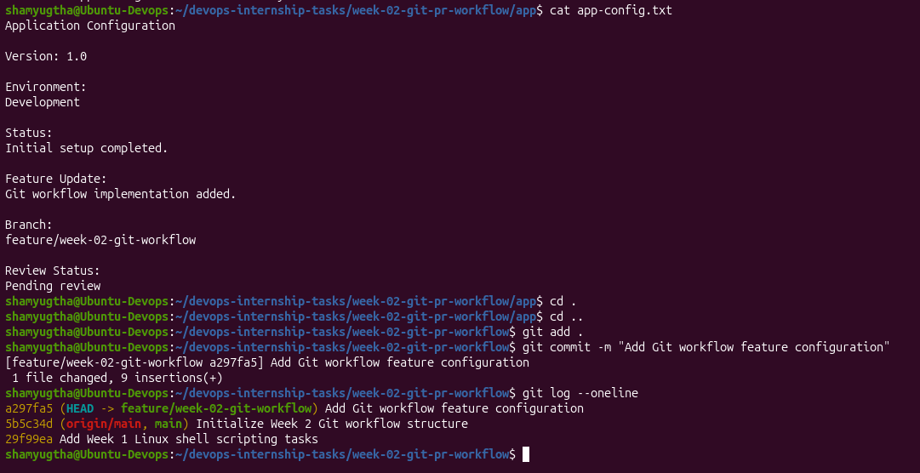

- Pull-Request-Creation
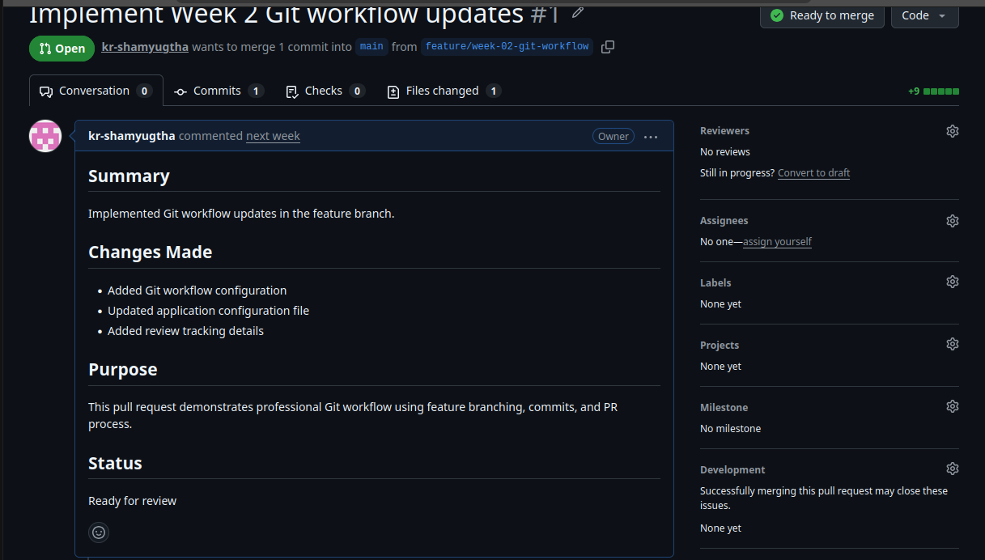

- Pull-Request-Changes-Review
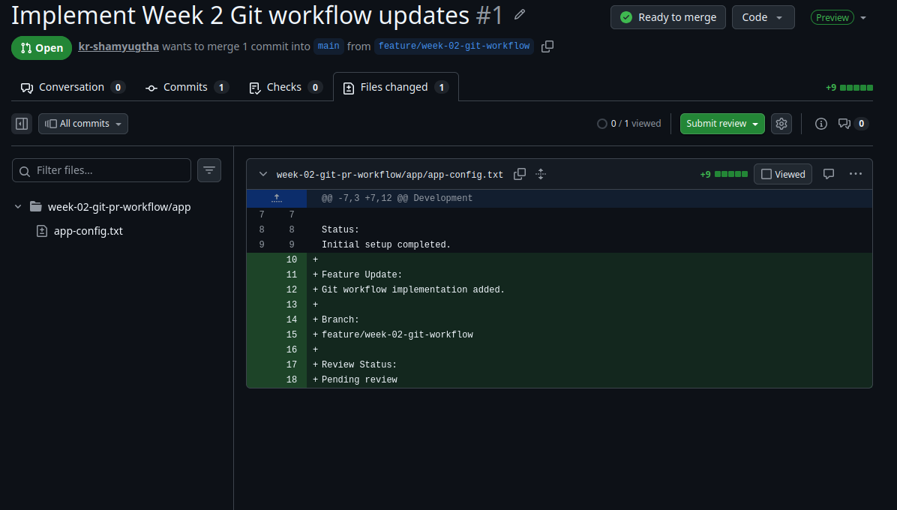

- Pull-Request-Review-Comment
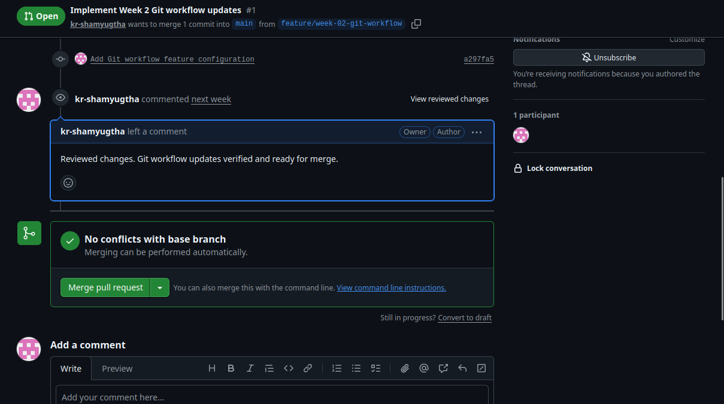

- Pull-Request-Merged
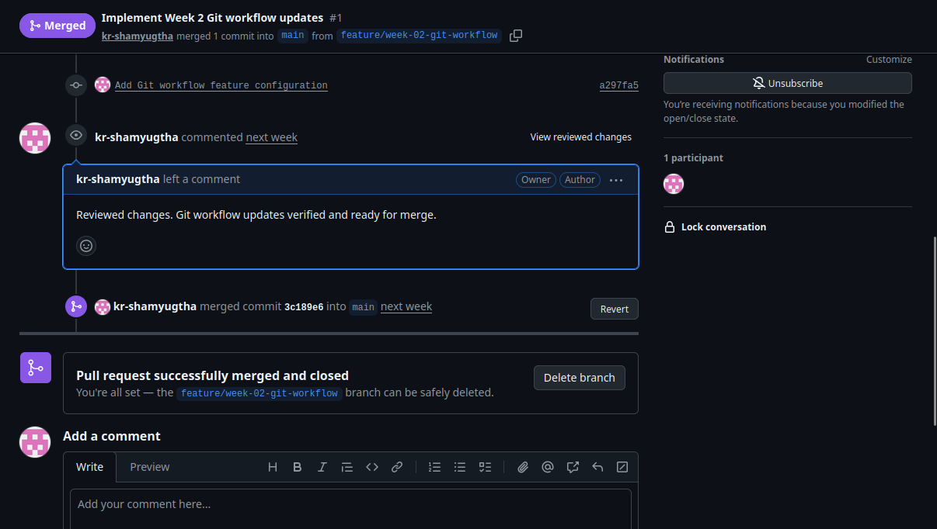

- Merge-Conflict-Generated
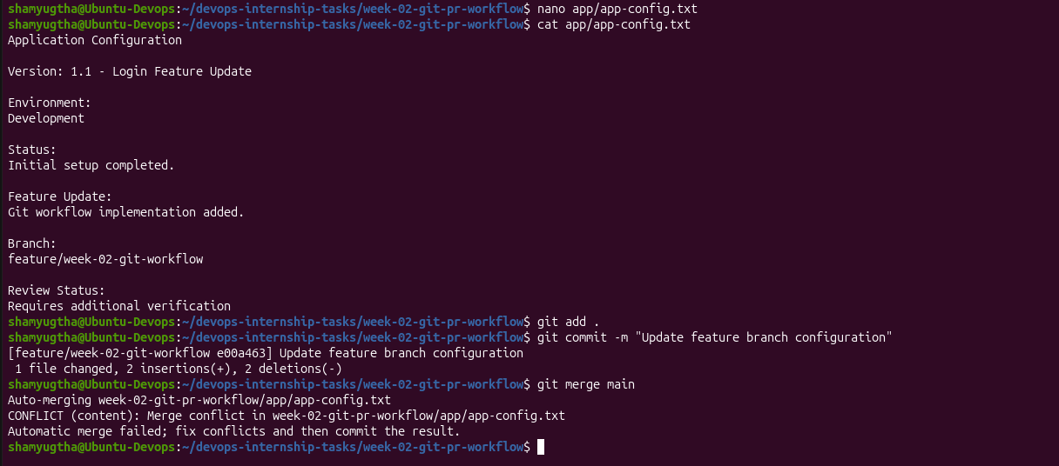

- Merge-Conflict-Investigation
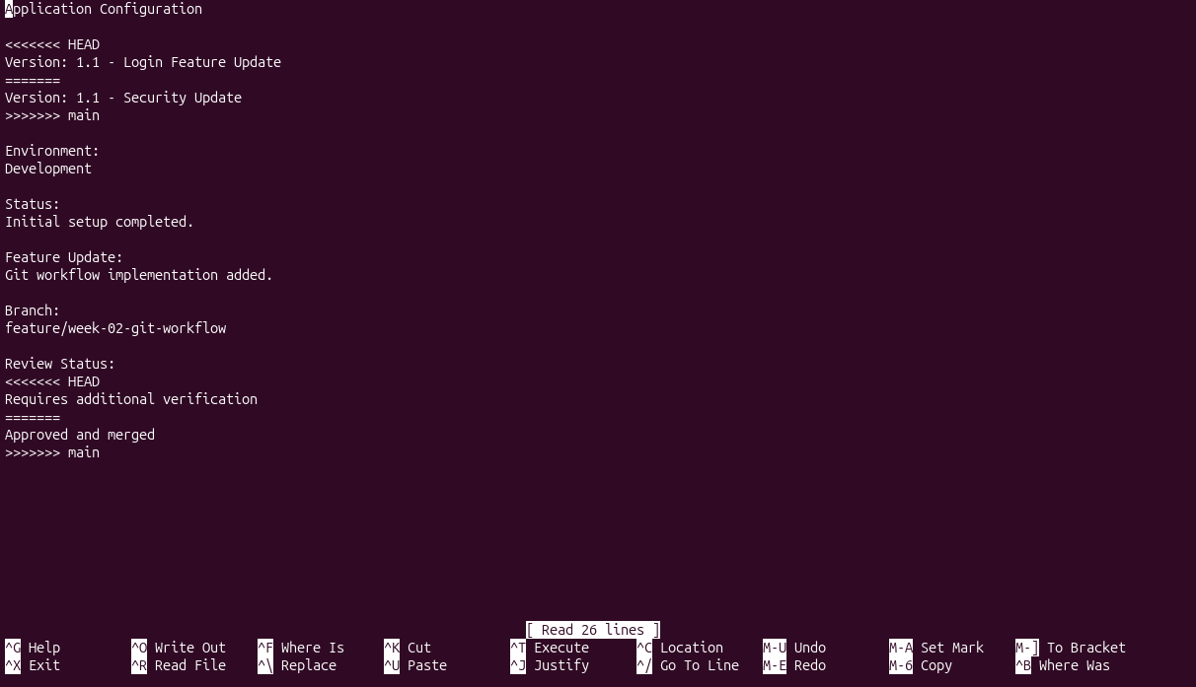

- Merge-Conflict-Resolved
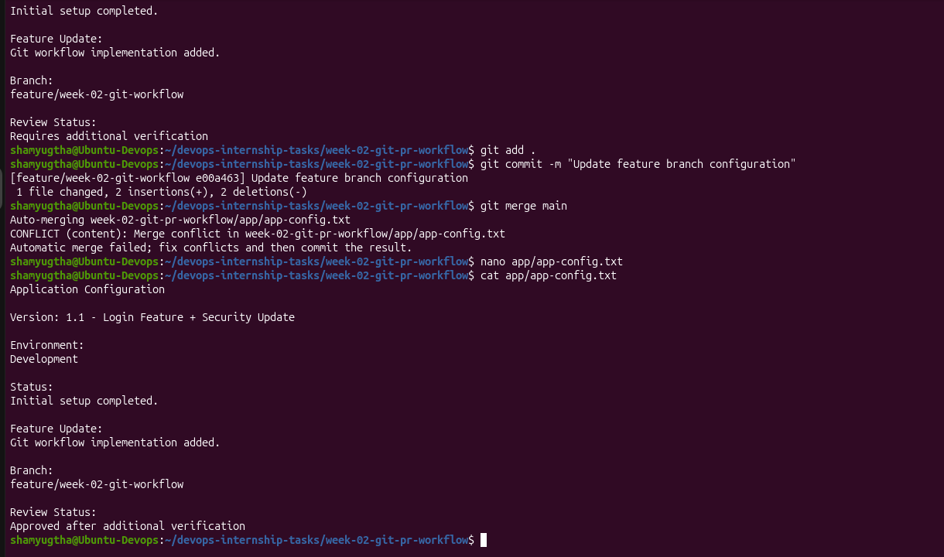

- Final-Git-History-And-Conflict-Resolution
